

Press Release Wednesday 27th March 2019

On Wednesday April 3rd at 11.15 am, the renovated Hawthorn footbridge over the Guiseley to Shipley railway line, near Baildon Station is being reopened. The bridge connects Fyfe Lane with Hawthorn View.

Representatives from Baildon Walkers are Welcome, Bradford MDC, Baildon Town Council , Friends of Baildon Station, Baildon Sustainable Transport Group, Northern Trains, Network Rail and other community groups will formally come together to reopen this important footbridge and welcome it back into regular use. The footbridge carries a walking route which connects the path along the River Aire with the centre of Baildon. It is an important route for local residents in the Fyfe Lane area and for walking groups like Walkers are Welcome who use the route for guided walks.

The major engineering task has been undertaken by contractors for Network Rail. A spokesman for Network Rail gave this description of the task and the challenges they faced:

The footbridge, in Baildon, West Yorkshire, is in a residential area and crosses a steep cutting with the Guiseley to Esholt railway line at the bottom. This made it very difficult to get a traditional crane to site, which is often the method used to lift out old bridges and lift in replacements.

The project team organised a Public Information Event in conjunction with the local council to talk through the project and listen to any concerns they may have.

The nearest access point was also one mile away – in Esholt- adding to the challenge of how best to remove the bridge, transfer it off-site and put in the new deck.

**Solution**

Network Rail working collaboratively with our framework partners Construction Marine Ltd developed a solution in the form of utilising two road-rail cranes, which entered the railway at the access point and drove along the track where they were positioned on either side of the bridge. The old bridge deck was lifted out and turned 90 degrees – parallel to the tracks – it was then taken to the access point on trailers, craned off and driven away.

The new footbridge was lifted into place using the same method.

In preparation for the possession, the existing deck was cut into small sections and lifted out using a lorry mounted crane on. The middle of the deck was left in place until the main possession to protect the overhead line equipment underneath.

The footbridge was due for renewal after it failed its assessment; it was found to be under strength and concrete from the bridge was in danger of falling onto the track.

**Not typical**

Jonny Ham, scheme project manager, IP SNE Renewals said: “This was a challenging location due to the steep cutting and surrounding urban area narrowing our options and using two road rail cranes was one of the few possibilities that would’ve worked for us. We even looked at lifting it out using a Chinook helicopter.

“The lack of space also meant that our site compound was approximately 1 mile away from the bridge.”

See photograph below. Other photos available of the work in progress.

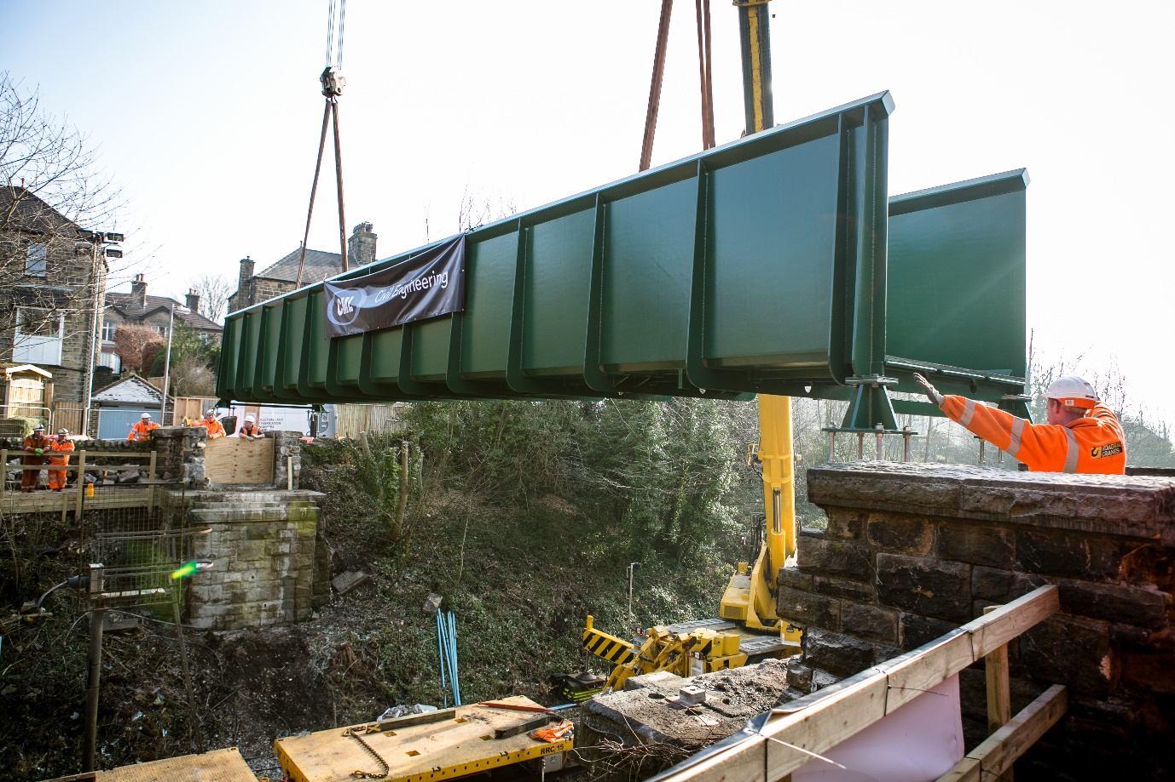

Baildon Walkers are Welcome is one of three Walkers are Welcome communities in Bradford. Bingley and Burley in Wharfedale are the two others. Information about Baildon Walkers are Welcome is available at:

<https://baildonwalkersarewelcome.org/>

Baildon Walkers are Welcome is supported by Baildon Town Council.

For further information, please contact Bob Davidson, chair of Baildon Walkers are Welcome on 07761 027725 or email [davidsonbj@tiscali.co.uk](mailto:davidsonbj@tiscali.co.uk)