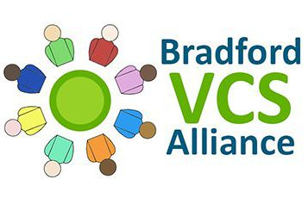

Asset Based Community Development

Small Grants

Of between £250 & £1000

Are available to groups that are involved in organising a whole range of community activities such as;

Lunch Clubs for the Elderly.

Parent & Toddler groups.

Art Classes

Keep fit Classes

(other activities can be considered)

Activities & Projects will be considered if;

Members of the local community are involved in the delivery of the service and that the project can show that they;

* Have the potential to improve the participant’s Health & Wellbeing.
* Promote community networks & friendships circles.
* Enable groups to have a greater say in the group’s future plans & aspirations.

The funding must also be spent within 6 months of receipt of the grant

If you would like to apply for a grant, you can email Bradford VCS Alliance on [info@bradfordalliance.org.uk](mailto:info@bradfordalliance.org.uk) or phone them on 01274 306624.

**The closing date for completed application forms is Noon on Friday May 31st**

You can also contact

Michael Pascal from Community Action on [muppett@cabad.org.uk](mailto:muppett@cabad.org.uk) / 01535 665258 to arrange for him to come and talk over any questions or queries you have regarding applying for a grant.

Supported by

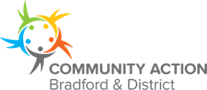 [](http://www.google.co.uk/url?sa=i&rct=j&q=&esrc=s&source=images&cd=&cad=rja&uact=8&ved=2ahUKEwjqkJjwicPhAhXkmOAKHbPiDpgQjRx6BAgBEAU&url=http://cdmsafe.org/bradford-council-district-wide/&psig=AOvVaw1MgkzHw2f13B-9tfbuoktR&ust=1554901569520110)