# Community Development Work – Quarter 2 Report

## Introduction

Please find below a short report for the period 1 July 2019 to 30 September 2019.

## Template Information

This quarterly report is based on the programmes we stated that we would like to develop in our Year 2 Plan (2019-2020) submitted in March 2019 to Baildon Town Council.

1. **Continue to develop the community development partnership we set up in April 2018**

Met with partners on Wednesday 14th August 2019. Partners all agree that it is still useful to meet up and all partners funded by Baildon Town Council for the delivery of community development work have confirmed that they are keen to continue participating in these partnership meetings. We identified a number of potential wider partners at our meeting (see list below), to share information with and to keep up to date with and this year different members of the group are going to be taking responsibility for facilitating different meetings throughout the year, including inviting other relevant professionals for the benefit of mutual exchange of information and building appropriate professional networks and friendships.

**Proposed Partners**

* Gill Blamires
* Donna - MIND
* Bev - Alzheimers
* Carers’ Resource
* Age UK
* Churches Together in Baildon
* Pharmacy
* Home First
* Connect to Support
* Mental Health i.e.  Cellar Project

 Our next meeting will take place on Wednesday 30th October at 10.30am at the Link – Carol will lead in liaising with the Alzheimer’s Society.

## Set up a new sustainable volunteer led Bibliotherapy group to benefit local residents, including those living with mental health conditions

Continued raising awareness of this new group this quarter, including utilising social media advertising, local posters and volunteers have attending local community events to tell people about the group. Jim, a local resident has led 2 sessions so far on 4th and 18th September. Our first session attracted 5 residents and our second session attracted 3, so quite low numbers and we will see how the group progresses and whether there is interest in continuing it after a couple more sessions. See poster below for details of the next two sessions that will run in October.



## Set up a new sustainable volunteer led activity session at Heygate Community Lounge

Continued excellent progress with this group which was set up in quarter one and which continues to attract 7 or 8 residents on average from Heygate to each session, including those affected by chronic health conditions. I’m pleased to be able to report that local residents are engaging with our two new volunteers now about future plans and really taking ownership, including one resident bringing a quiz along to the two most recent sessions that residents thoroughly enjoyed. As a community development worker I’ve already stepped back from the group, but I’m still offering a little bit of support and have just arranged a safer people handling training session for both volunteers to attend as one resident is sometimes helped home with a wheelchair and others may need an arm. This course is scheduled to take place mid-October time at the Link and I will extend the invitation to participate to other volunteers.

The amazing thing about this group is that by being volunteer led there isn’t the burden of finding sustainable funding for the continuation of the group. Also, as the group is at the heart of those living in this area it is accessible in a way that activities at other centres aren’t. Indeed, some of the residents have carers coming in up to 3 times per day and struggle to get out and about so this group has really made a huge difference to reducing loneliness and isolation and to neighbours getting to know each other better.

In speaking to one of the volunteers, we have begun to explore whether there is scope to consider extending this work to Ivy Bank or Greenbank Court in the future.

1. **Look into the possibility of a Baildon breakfast or luncheon scheme to benefit residents who are struggling to feed themselves and/or families. Community development partnership keen to support – the idea being that different venues might contribute on different days.**

At the Link our Youth workers have led on the delivery of sessions around quick/cheap/healthy meals on a Monday evening drop in session and you can read more about this in our second quarter youth report. In addition we continued to signpost people to the lunch box scheme running at St Hugh’s Centre and St James’ Church over the summer. The Link community cafe serves 24 lunches on average each week. We intend to come back to our discussions around the possibility of a Baildon breakfast scheme at future community development partnership meetings. Local residents can come along to the Link and enjoy self serve toast, but this is not widely advertised at the minute. In addition, we continue to offer emergency food parcels and uptake has been low this quarter (we have distributed 3 parcels this quarter).

1. **Arrange another intergenerational Annual More In Common Fun Day bringing people together.**

Completed quarter 1 – see quarter 1 report.

1. **Explore a central directory of community activities that partners can contribute to.**

In progress. Familiarised myself with the Town Council online calendar and set up an initial meeting early in quarter two with Ruth Logan from Baildon Town Council to explore potential options. Rachael will be undertaking the bulk of this development work in quarter 3, gathering a list of 20 organisational links to add to the new page Ruth has created, helping to promote community events across Baildon, encouraging local organisations to utilise the What’s On calendar on the Town Council website (or Ruth might be able to take things and post from the organisations own links), post things to Visit Bradford <https://www.visitbradford.com/events.aspx> and be added to the extra page below the what’s on calendar for community groups/events that Ruth has now created.

1. **Explore opportunities for further befriending work across Baildon in partnership**

Made 6 referrals to Donna at MIND for the new scheme called Community Companions. One resident has now had two visits and is enjoying the company of his new befriender. Other referrals are in the process of being matched by Donna, who has now trained up suitable volunteers.

1. **Continue to increase volunteering across Baildon, providing opportunities for wider agencies to recruit volunteers, including stalls at fun days and community events.**

This quarter we have recruited 4 new volunteers to support the activity days at the Link, along with 2 new trustees. We also engaged a dozen volunteers who supported all aspects of a healthy living event that took place at St James’ church mid-September, including leaflet design, delivery, practical tasks such as setting up and clearing away, refreshments and stallholders.

I arranged a Food Safety Awareness course in July and this has been successfully completed by 15 Baildon volunteers. I arranged a further Level 2 course and food allergy awareness training for key personnel involved at the Link (cafe staff and volunteers) and 3 of the 4 volunteers have successfully completed the training so far.

1. **Host activity taster events at different venues across Baildon in partnership**

An event in partnership with Bingley Bubble took place on 25th July, 10am to 1pm at the Link. Feedback was positive with two dozen stalls including stallholders from Dementia Friendly Baildon, the Link, Baildon Town Council, Healthwatch Bradford, Alzheimer’s Society, Lets Connect, Making Space, Positive minds and Bingley Bubble representatives. All stallholders raised awareness of projects and around 100 attendees benefitted from the event, taking away relevant literature and having free blood pressure checks. Dance On demonstrated a dance workshop and volunteers attached to Bingley Bubble served refreshments alongside the Link cafe team. After the event residents have reported following up on projects of interest. Baildon Community Link gained 12 referrals across our Centre.

One event has also taken place this quarter (a Denso fun day) in support of the Youth Partnership group. We advertised the event on local notice boards in the area including at Denso and St James’ church as well as via our social media channels. A good number of local young people participated and we worked in partnership with Baildon Youth Council leaders. Those involved enjoyed pond dipping as well as the board trail.

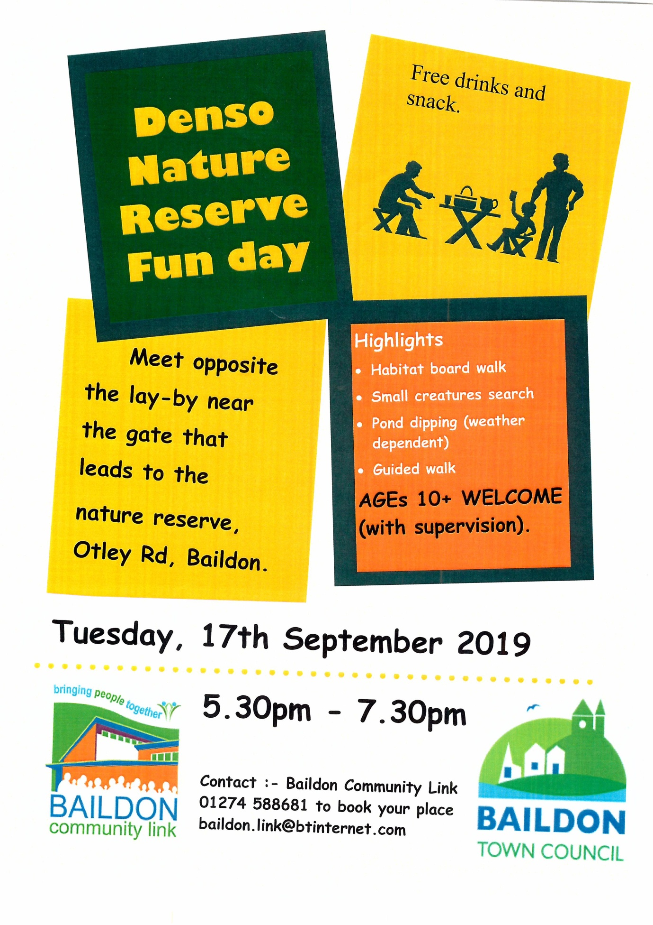

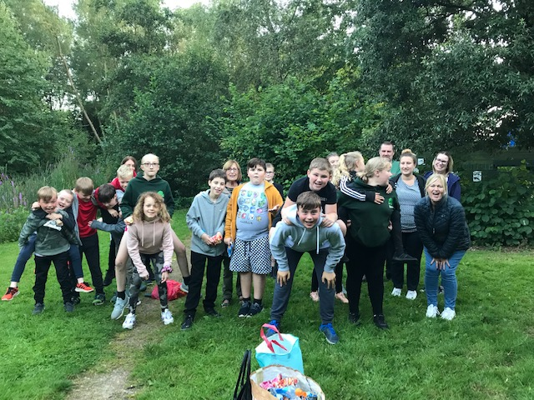

1. **Run a series of health and wellbeing events at different venues across Baildon in partnership**

Building on development work undertaken in quarter 1, two health & wellbeing events have taken place in quarter 2. The first event was a partnership event with Bingley Bubble and it took place at the Link on Thursday 25th July, 10am to 1pm (mentioned under section 9 of this report) and the second took place at St James’ church on Tuesday, 17th September (see poster below). 630 posters were delivered by staff and volunteers and also two adverts in the local press. The poster was designed by a local volunteer, Czes and I engaged with a number of potential partners. 17 rather than 14 turned up to have stalls on the day, including a good mix of organisations, nhs representatives, a local pharmacy, Baildon Town Council, Bradford Energy Team, Worth Connecting and local support groups. In addition we had demonstrations of a seated exercise class and a Dance on demo along with a diabetes prevention talk. A good event, good footfall, excellent partner support and feedback. Thank You to those who supported in any way.

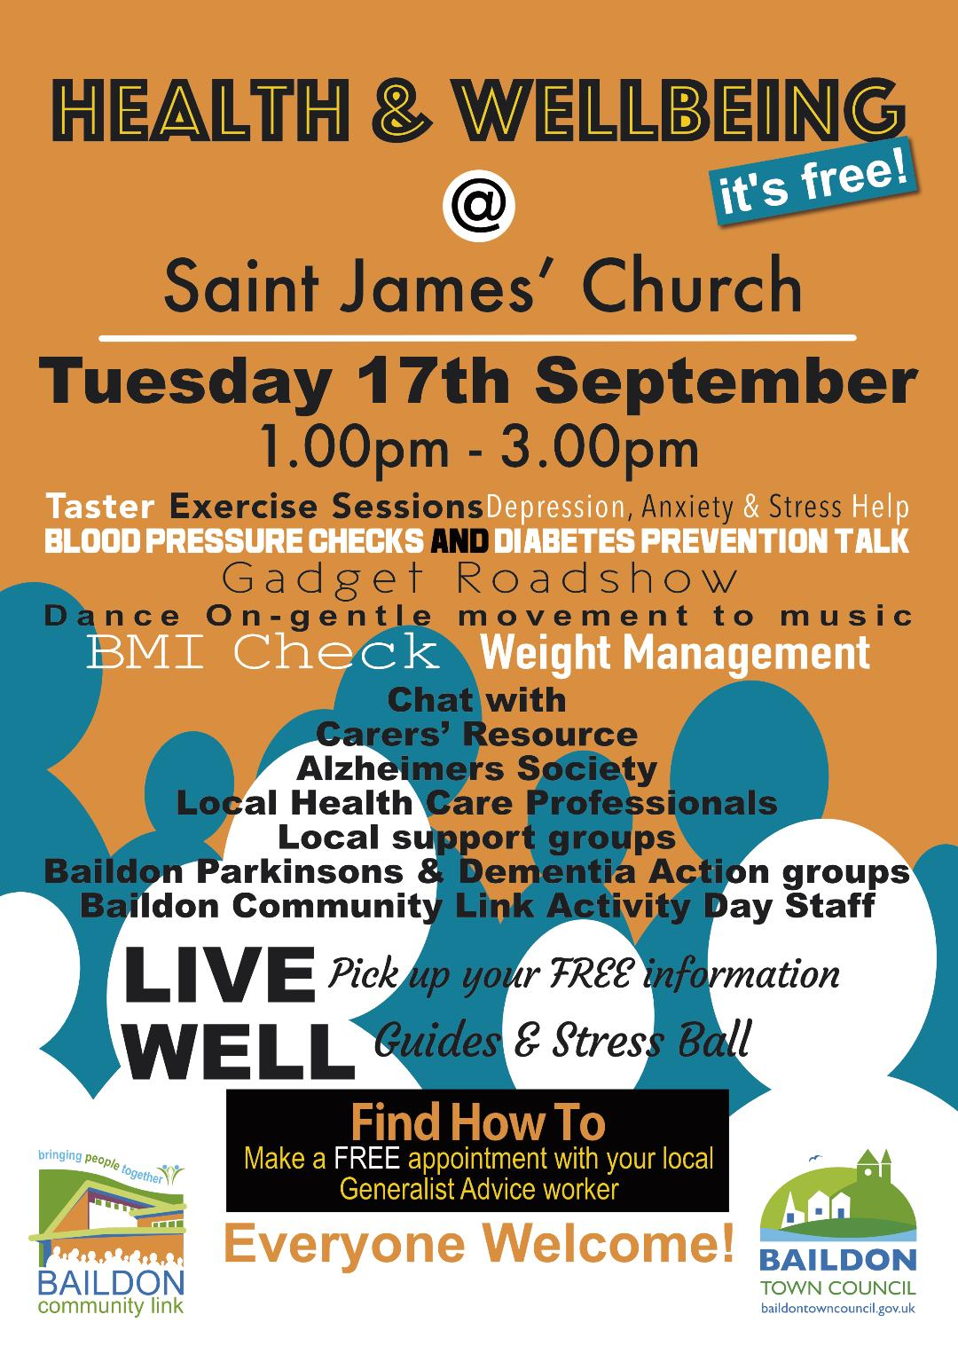

**Ongoing Work**

I have continued to support individuals and groups including provision of food parcels and referring local residents to the advice worker who is based at Baildon Link on Tuesday mornings. On average half a dozen significant conversations take place each week with local residents popping into the Centre seeking my help or support, as well as with representatives of various organisations. I’ve offered a bit of support to our Sunday film club volunteers as well as to our Parkinsons group, both groups continue to run well. I’ve also promoted a Knitting Poppies appeal on behalf of the bull who hope to do a display for Remembrance.

A dozen referrals from Social Services received, including plans to do a joint visit to one local vulnerable resident on account of my long term professional contact with that resident.

Significant amounts of my time have also been spent working to support the ongoing smooth running of our social activity days at the Link after some significant changes. Funding changes mean that we have sought to work in a different way, whilst continuing to support existing users of our former Tuesday and Friday social day care groups.

Early work has taken place in thinking through sustainability at the Link with trustees and further development work around business planning, volunteer role descriptions and effective sub committees is planned, including training through CABAD (Community Action Bradford & District).

**Quarter 3 Development Work**

Baildon Link look forward to continuing our partnership with Baildon Town Council during the coming third quarter, including plans to further develop our volunteering support at the Link and support for other organisations seeking volunteers.

I would welcome any constructive feedback from Town Councillors. If you feel I could support any other specific initiatives or contribute to other Town Council priorities then I’d be keen to do so. Thank You for your ongoing support.

**Lucy Maddison**