**BAILDON ZERO WASTE GROUP (PLASTIC FREE BAILDON)**

|  |  |  |
| --- | --- | --- |
| **Image result for logos zero waste**  **Baildon** | ***A Special Interest Group of***  ***Baildon Friends of the Earth.***  **Application for funding to Baildon Town Council Environment Committee.** | ***C:\Users\Mervyn\AppData\Local\Microsoft\Windows\INetCache\Content.MSO\2B6917BF.tmp*** |

**Aim: to reduce plastic glasses / litter in the centre of Baildon after summer outdoor events (such as the Harley Davidson weekend).**

Baildon Zero Waste Steering Group was formed in autumn 2019 following a well-attended public meeting about concern to reduce plastic waste. We currently have £70 held for the Steering Group by Baildon Friends of the Earth.

The Baildon Zero Waste Steering Group is very concerned about the large amount of discarded plastic “glasses” which litter the centre of Baildon after summer outdoor events. The littering is unsightly, and collecting up the non-reusable plastic “glasses” and sending them for recycling has a cost both financial and environmental (and may not always be possible if they are not clean enough).

We would like to trial a scheme to encourage outdoor drinkers in the centre of Baildon to use the reuseable sort of plastic “glasses” which are nowadays often made available at large scale sporting and musical events. These can be made to simple or colourful designs (see two examples below).

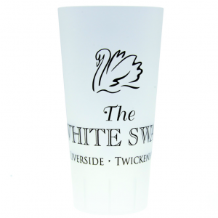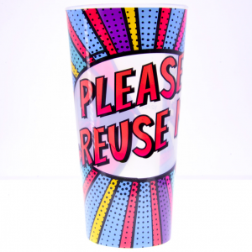

We are therefore seeking the financial support of Baildon Town Council Environment Committee for the purchase of 3000 reusable plastic “glasses”, **subject to us gaining the support of the landlords.**

**The scheme would involve:**

* The reusable “glasses” being shared around the three pubs in the centre of Baildon and Bar 12 (as these are the main outlets for outdoor drinking).
* The glasses would carry an attractive design including the Zero waste and Town Council logos, along with an eye-catching slogan such as “Re-fill Not Landfill”.
* People purchasing drinks for consumption outdoors would be asked to pay a deposit of £1 for a reusable “glass”. They would return it when they finished and the £1 would be returned to them.
* If anyone chooses to keep their “glass” as a souvenir, they would forfeit their deposit.
* Landlord would need to commit to purchasing additional “glasses” to replace those that were not returned.

**The cost:**

We would seek at least three alternative quotes before proceeding to purchase. Website evidence indicates that 3000 colour printed reusable “glasses” would cost around £2000.

We hope that the Environment Committee might consider this a worthwhile scheme to support for the residents of Baildon and the benefit of the wider environment.

*Julia Donoghue and Chris Flecknoe (For the Steering Group of Zero Waste Baildon)*