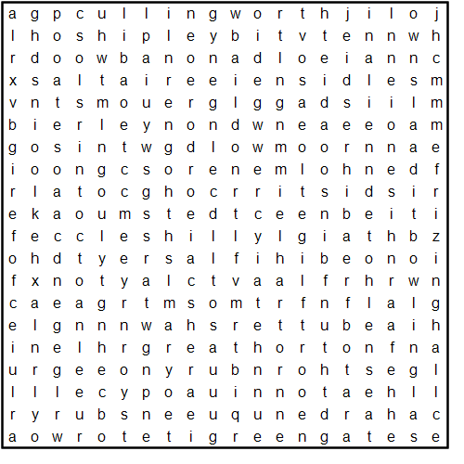

**Areas in and around Bradford**

**Baildon**

**Bierley**

**Bowling**

**Buttershaw**

**Clayton**

**Cullingworth**

**Denholme**

**Eccleshill**

**Fagley**

**Frizinghall**

**GreatHorton**

**Greengates**

**Harden**

**Heaton**

**HolmeWood**

**Idle**

**LowMoor**

**Manningham**

**NabWood**

**Oxenhope**

**Queensbury**

**Saltaire**

**Shelf**

**Shipley**

**Thornbury**

**Thornton**

**Tong**

**Tyersal**

**Undercliffe**

**Wilsden**