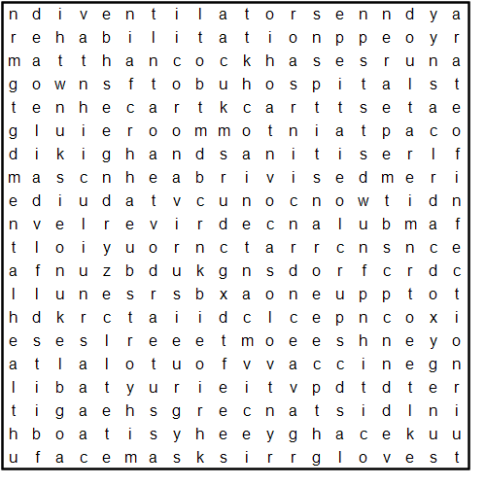

**COVID 19**

**Ambulancedriver**

**Anxiety**

**CaptainTomMoore**

**Coronavirus**

**DailyBriefing**

**Deaths**

**Distance**

**Doctors**

**Facemasks**

**Furlough**

**Gloves**

**Gowns**

**Handsanitiser**

**Hospitals**

**MattHancock**

**MentalHealth**

**NHS**

**Nightingale**

**Nurses**

**Oxygen**

**PPE**

**Rateofinfection**

**Recovery**

**Rehabilitation**

**Remdesivir**

**TestTrackTrace**

**Vaccine**

**Ventilators**