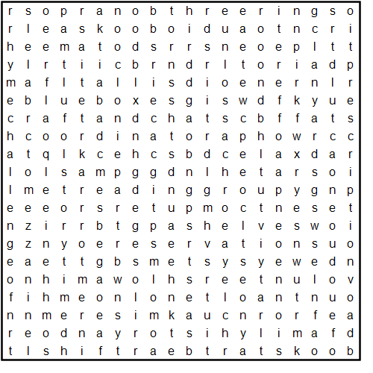

**Library**

**audiobooks**

**blueboxes**

**BookstartBear**

**Borrowbox**

**computers**

**Coordinator**

**craftandchat**

**DBScheck**

**Deweysystem**

**discharge**

**displays**

**ebooks**

**FamilyHistory**

**lanyards**

**mezzanine**

**Netloan**

**password**

**Prescription**

**Readinggroup**

**reservations**

**RhymeChallenge**

**shelves**

**shift**

**Soprano**

**staff**

**Storytime**

**Tallis**

**ThreeRings**

**till**

**volunteers**