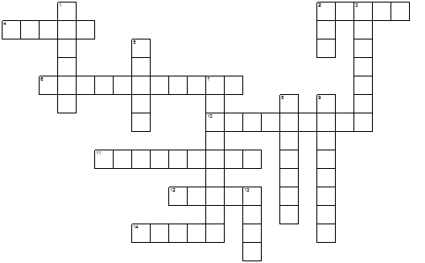

**British Prime Ministers post WW2**

Across

* 2. Military rank, but grey suit (5)
* 4. B LIAR, about WMD, for instance (5)
* 6. MADE SO GHOUL : cadaverous features (11)
* 10. Lord Jim (9)
* 11. Trademark cigar (9)
* 12. Sent troops to fight in Korea (5)
* 14. Shortlived premiership and not colourful (5)

Down

* 1. Pipesmoker from Huddersfield (6)
* 2. HER SEAT : pole dancer? (3)
* 3. Blond and unkempt (7)
* 5. Took UK into EU (5)
* 7. Supermac, tainted by Profumo affair (9)
* 8. NO CREAM for Dave (7)
* 9. Good at roofing cottages? (8)
* 13. Suez crisis was his downfall (4)