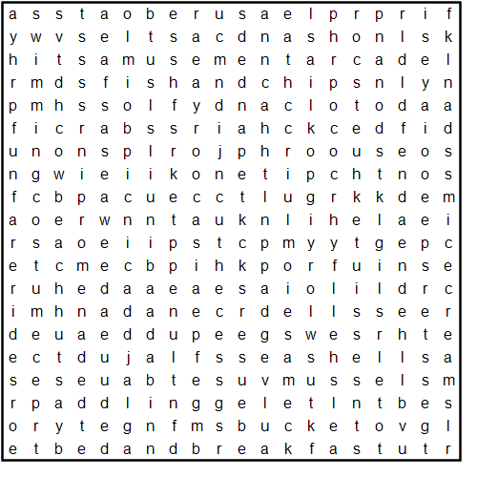

**Seaside holidays**

**amusementarcade**

**beachhuts**

**bedandbreakfast**

**bucket**

**candyfloss**

**cockles**

**crabs**

**deckchairs**

**donkeyrides**

**fishandchips**

**funfarerides**

**hightide**

**icecreams**

**jellyfish**

**mussels**

**paddling**

**picnic**

**pier**

**pleasureboats**

**promenade**

**PunchandJudy**

**rockpools**

**sandcastles**

**seagulls**

**seashells**

**seaweed**

**shrimps**

**spade**

**swimmingcostume**

**waves**