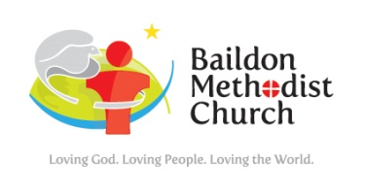****

**SUBMISSION TO THE ICH BUILDING AND REDEVELOPMENT SUB-COMMITTEE.**

I write to contribute to your consideration and debate about the future of the ICH and options for locating Council activities.

We are deeply grateful to Baildon Town Council for your recent support for the building refurbishment programme at Wesleys, and to the continued operation of Wesleys Café (as soon as Covid restrictions permit).

We feel it may be helpful for you to know that:

1. Whilst our premises (both Wesleys and The Fold) were very heavily booked for community activities prior to the Covid pandemic, the future demand for rooms for community activities is uncertain. We have kept in close contact with our hiring groups, but it is not clear at present as to whether all the groups will have survived and will be able to resume face to face meetings in our premises anytime soon. We are aware that some of the groups which have moved to on-line meetings may continue to meet in this way rather than pay for room hire.
2. However, we are committed to keeping open the diary slots for our regular hiring groups at least for the coming months until the future arrangement become clearer.
3. Although we would not be able to offer exclusive use for space for a library of anything like that currently used by the Library at the ICH, we are always open to looking at imaginative shared usage.
4. The new toilets which we have been creating during the close-down of the premises are nearing completion (end of January is the target date). Once this work is completed, this will liberate more space, and we would be very pleased to meet with Council Officers or Members to look at whether any of our rooms would be suitable as a Council Office. We can see definite possibilities for this and would be delighted to work in close partnership with the Town Council to serve our community from a setting which, when things return to anything like normal, has a high footfall and is central to Baildon.

If there are Councillors who have yet to visit Wesleys or The Fold, we will be delighted to arrange for a guided visit and answer any questions.

*Chris Flecknoe, on behalf of Wesleys Community Hub*