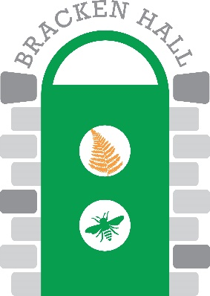

**Bracken Hall Countryside Centre: Manager’s Report, January 26th 2021**

Richard White

**Preparation for re-opening of BHCC.** A limited reopening of the BHCC site was given in October 2020 by the Clerk of BTC after the Government legal requirements were met and a Covid-19 secure workplace certificate was issued. Site visits to the then recently reopened Bradford Industrial Museum, facilitated by Dawn McIntosh, and Baildon Community Link, facilitated by Lucy Maddison, plus a discussion about the St John’s Church Hall with Sarah Baxter, and Baildon Library with Rachel Gallagher, plus associated documentation, all provided valuable insights into what was possible at BHCC. Risk assessments were prepared and approved for a partial reopening of the site, and COVID-secure site status was granted due to the interventions put in place by the BH Manager with the assistance of a number of volunteers. These interventions included the removal of hands-on exhibits, decommissioning of hand dryers and installation of paper towel dispensers, hand sanitiser stations, appropriate signage, and the development of appropriate protocols for staff/volunteers and visitors including NHS Track and Trace. The Classroom was reconfigured to be the staff/volunteer safe relaxation zone, with no public access. Refreshments were not available to visitors.

**Types of opening at BHCC.** BHCC re-opened on a one-off trial basis on November 1st. This was for pre-booked family groups only, chaperoned by a designated volunteer. Access was limited to the Exhibition Room where each group had sole occupancy at any one time, and to the toilet and Wildlife Garden (which had shared access and a strictly enforced one-way system). The second national lockdown soon followed, followed by Tier Three status and the third national lockdown. Throughout all of these, indoor access was prohibited, but the Wildlife Garden remained available for either ‘recreation’ or ‘exercise’. Opening has been determined by the weather forecast (sun is a requirement when volunteers/staff are spending most of the afternoon outside!). The garden has been open on pop-up basis, often with very little notice (on Facebook and the BTC website). Entry to the site has been managed on the gate rather than by pre-booking, with numbers on site strictly limited. Visitor numbers have ranged from a minimum of 4 (on Christmas Eve) to 19 (on Saturday 5th December), with typical attendance being about 10. We have held 10 pop-up open garden events. All visitors have walked around the garden as part of a longer walk in the area, and the vast majority have attended due to seeing signs posted in the vicinity.

**Volunteering situation.** Not surprisingly, many of BHCC’s regular volunteers are currently unavailable to open the Centre (due to shielding, etc.). A number of volunteers have continued to work in the garden. In terms of opening for the public, volunteer numbers have fluctuated between 3 and 5 depending on the status of the prevailing coronavirus restrictions. Those volunteers that have opened the site for the public have all indicated that they were comfortable with the provisions made. They have also expressed the wellbeing benefits of the camaraderie of volunteering at BHCC.

**Creation of BHCC Planning Team.** Extending the scope of input by volunteers has long been discussed for BHCC. The idea is to devolve some responsibility to keen third parties that are already involved with the Centre as volunteers. Several volunteers have expressed an interest to be involved. A meeting on Zoom has been provisionally scheduled for Thursday 4th February at 7.30pm.

**Funding application for building works update.** This item has been dealt with elsewhere in the meeting. The considerable efforts of Mr Eddie Nash in the pursuit of this external funding are to be acknowledged and commended.