# Community Development Work – Quarter 4 Report

## Introduction

Please find below a short report for the period 1 January 2021 to 31 March 2021.

## Template Information

This quarterly report is based on the community development work Baildon Community Link has delivered for Baildon Town Council in the fourth quarter period outlined above. The third National Lockdown (5th November 2020 onwards) fell during this reporting period and affected our work, alongside the additional impact of COVID during the whole quarter. As a result of the lockdown we focused on projects to reach the most vulnerable in our community as well as accommodating 3 AA meetings and a church booking at the Link that could operate under an exemption.

**Main Projects during Quarter 4**

1. **Pocket Hugs**

This quarter our first project was to engage local Baildon residents with knitting pocket hearts to be distributed to all residents living in local nursing and care homes as well as all sheltered housing and some wider older or vulnerable residents (300 residents). All nursing homes have been covered at the time of writing this report and we will finish deliveries with the help of local volunteers to all sheltered housing and wider vulnerable residents by the end of quarter 4. Each heart is accompanied by a message of support and an invitation to ring the Link for a chat or to let us know if there is any way we might be able to support or signpost for appropriate support. 20 local residents have knitted, stuffed and/or sewn hearts together ready for delivery, supported by volunteers delivering the hearts to local residents, homes, etc

This project was a simple idea and feedback has been positive across the board. Recipients have been pleased to receive the hearts/letters, volunteers involved have been pleased to have an activity to distract them during COVID and all homes and sheltered housing complexes in Baildon were keen to be included in our scheme.

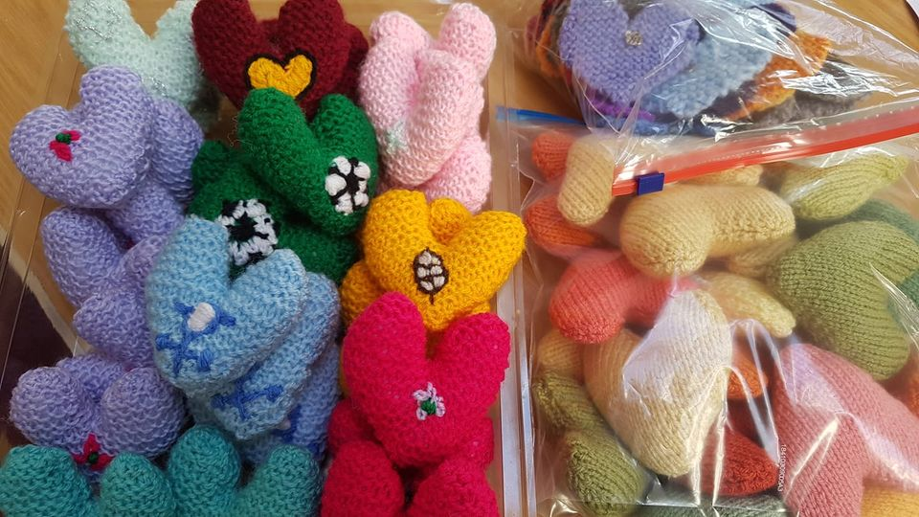

1. **Recipe cards**

Our second project is ongoing and it is a community inspired 3 ingredient set of healthy recipe cards- salt, pepper, oil, herbs not counted - the aim is to encourage simple, healthy cooking on a budget - we will deliver these recipes once ready and we will include breakfasts, lunches, dinners, desserts along with signposting to Change4Life for further inspiration for those online and gauge interest in a future possible cooking on a budget course. The recipe cards will be included in food parcels going out across Baildon.

An application to ABCD for £750 has been submitted to cover the cost of professional design, printing and laminating 250 sets of 12 recipe cards (total 3,000). We will have 36 3-ingredient recipes in total (32 have already been submitted by the local community at the time of writing). The funding will allow for a professional job if successful. Within the bid, we've asked for funding to also cover the cost of putting 45 boxes of ingredients together, 20 for our over-55s club and 25 for beneficiaries of St Hugh's community kitchen so that they have the set of cards and ingredients to make one of the recipes. If successful, our youth club members will be asked to write a letter of support to go to our over-55 club members with the boxes.

Without funding our project is still possible but printing will be done in house. We anticipate completing the project before the end of the financial year or early in the next financial year beginning April 2021.

1. **Arts project**

Our third project is a Community Arts project - it's simple - anyone of any age can do a simple image to reflect what makes them feel healthy and happy during lockdown and send this to baildon.link@btinternet.com or drop in our lobby so we can share the images with the wider community through social media. The project has been advertised widely including at local primary schools and amongst local partners. The deadline for entries is end March 2021. Any media - drawing, painting, collage, felting, knitting etc can be used - A4 or smaller encouraged. At the point of writing this report we have currently received 12 entries which we have displayed on our notice board at the Link and which we are sharing on our social media sites also.

Depending on receiving suitable entries we will possibly undertake a bigger project whereby we choose one image and have it blown up in size then chop it down into lots of individual squares for residents across Baildon to decorate using any media of choice to create a possible large mixed media project – a local graphic designer is advising us if any image is suitable to blow up once all entries are received.

A volunteer produced the poster below to help us with advertising.

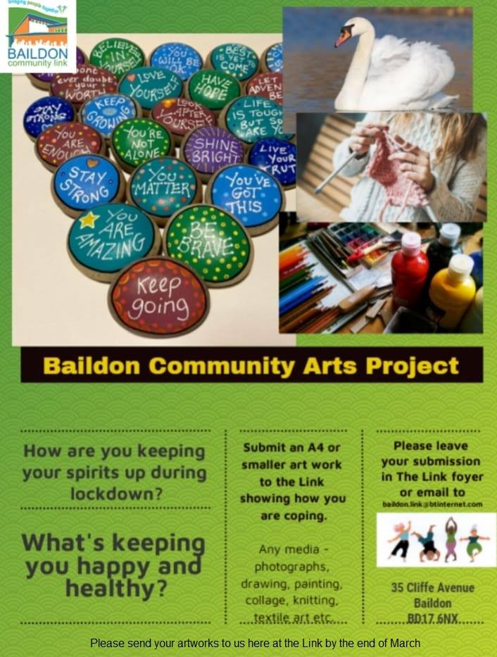

**Prospective New Project - Exercise to stay well.**

I've submitted a wellbeing grant application based on the Link paying for an exercise tutor to produce a simple exercise video for our website, along with the production of boxes containing an exercise sheet, resistance band, stress balls, etc to deliver to former seniors and seated exercise class members (cost approx £800). Outcome pending.

**General**

We're continuing to undertake befriending support, activity packs, food parcels, etc to support other local provision.

Our youth project and community development work has come together to support Denso through posters designed around not stealing daffodils and not stealing or causing cross contamination with frogspawn, alongside making plans with the youth project and over 55s around the recipe card boxes and future intergenerational work.

Our Baildon thankfulness banners have been able to remain in situ on the roundabout again during this final quarter which is great. We have also been able to promote our other local activities and initiatives alongside those of other groups, via local notice boards as well as through our website and other social media channels.

See link to our website below where you can find further information about our activities, forthcoming events, our current operational timetable and our contribution towards supporting some of our more vulnerable residents in Baildon during COVID:

<http://baildoncommunitylink.co.uk/site/>

**Partnership Working**

We continue to enjoy strong local links with a wide array of local individuals and organisations. George, our new Communications Volunteer continues in her role of Baildon Liaison Meeting Group representative, ensuring that the Link can share any useful information, keep abreast of other locality work and feedback relevant information across the organisation/wider community as appropriate.

I’m waiting for the date to attend the locality-level workshops being led by Impower (an exciting opportunity to share information and build wider connections that will potentially benefit residents from the Baildon area).

In addition to our ongoing local partnership working across Baildon, our strong links with MIND continue which is particularly helpful in ensuring that local people receive the appropriate telephone befriending support, including MIND being able to befriend clients in Baildon who might live in local nursing homes as long as they have a phone.

**Signposting**

We continue to signpost half a dozen local residents to the most relevant services each week, including advice work if appropriate, opening our Community Centre and manning our telephone lines from 10am to 4pm each day. In a lockdown situation we retain permissible activities and keep our lobby open for the safe exchange of goods including food parcels, jigsaws, etc

We are now focusing on completing the projects outlined above ready for the new financial year. In addition we are working on updating plans for our reopening on 12th April subject to there being no changes to Government advice. However, initially on 12 April it will only be for individuals to drop-in or those in a bubble indoors or for exempt activities/support groups of up to 15 people as the guidance also states that indoor events that bring people together - even if they do not mix with other households - must not run until Step 3 (17th May). On 17th May if we are bringing people together we are only allowed up to 6 people indoors or two households. It is not until 21 June when we will have to wait to see how the Government relaxes the rules and the impact to the Link.

**Support Work**

Telephone lines remain open 10am to 4pm each day with an ansaphone service alongside messenger option via Facebook.

The Link is manned from 10am to 4pm each day and we continue to support the vulnerable and operate a safe exchange system utilising our lobby for jigsaws, wool, food parcels etc as well as our outreach work.

**Quarter 1 (1st April 2021 to 30th June 2021) Development Work**

Baildon Link look forward to continuing our partnership with Baildon Town Council during the next financial year and we will attend the Community Committee on Tuesday 16th March 2021.

I would welcome any constructive feedback from Town Councillors. If you feel I could support any other specific initiatives or contribute to other Town Council priorities then I’d be keen to do so. Thank You for your ongoing support.

**Lucy Maddison**