**Youth Quarterly Report**

**Baildon Community Link Youth Club**

**Third Lockdown (!)**

Firstly, we hope you are all well. Rachael and I are excited to do this third Lockdown with you!

Every Monday we will be doing a ‘ZOOM FOR ALL’ at 6.30-7pm

This will include a catch up with you and some games. The invitation will be emailed each week. Tuesdays will alternate between the delivery of activity packs and the opportunity for those who would like smaller group zoom catch ups at 6.30pm and 6.50pm. Please let us know if you would like to participate in a smaller group ZOOM.

|  |  |
| --- | --- |
| **DATE** | **ACTIVITY** |
| 18TH Tuesday January | Activity Pack delivered (RSPB Bird Watch and Photo Competition, planting seeds, bird feeder ball and treats) |
| C:\Users\Administrator\AppData\Local\Microsoft\Windows\Temporary Internet Files\Content.IE5\WBBUJRTI\Flame_Robin,_Eaglehawk_Neck[1].jpg25th Monday January  26th Tuesday January | ZOOM FOR ALL**C:\Users\Administrator\AppData\Local\Microsoft\Windows\Temporary Internet Files\Content.IE5\QGGGC5QM\Zoom-image[1].jpg**  C:\Users\Administrator\AppData\Local\Microsoft\Windows\Temporary Internet Files\Content.IE5\F14T9OQ1\Thetford_forest_dtab[1].jpg SMALL GROUP ZOOM’S |
| 1st Monday February | ZOOMC:\Users\Administrator\AppData\Local\Microsoft\Windows\Temporary Internet Files\Content.IE5\QGGGC5QM\Zoom-image[1].jpg |
| 2ND Tuesday February | Activity pack delivered (7th February is Safer Internet Day (safety sheet), Family quiz and prize for family, Valentine’s Day treat and craft) |
| C:\Users\Administrator\AppData\Local\Microsoft\Windows\Temporary Internet Files\Content.IE5\DGQ6B15B\Brighter_Rainbow_Heart.svg[1].png8TH Monday February  9TH Tuesday February | ZOOM FOR ALLC:\Users\Administrator\AppData\Local\Microsoft\Windows\Temporary Internet Files\Content.IE5\QGGGC5QM\Zoom-image[1].jpg  SMALL GROUP ZOOM’S |
| 15th Monday February | Person Talking Emoji Pictures To Pin On Pinterest - Loud Emoticon - Free  Transparent PNG Clipart Images DownloadZOOMC:\Users\Administrator\AppData\Local\Microsoft\Windows\Temporary Internet Files\Content.IE5\QGGGC5QM\Zoom-image[1].jpg |
| 16th Tuesday February🥞 Pancakes Emoji | Activity pack delivered **(**21st February Shrove Tuesday – PANCAKE COMPETITION send in your pictures of your pancakes, troll craft and savoury and sweet pancake recipes.) |
| 22ND Monday  23rd Tuesday | ZOOM FOR ALLSmiley talking on phone | Emoticons emojis, Smiley emoji, Smiley  SMALL GROUP ZOOM’S |
| 29TH Monday February | ZOOM |
| 30th Tuesday February | Zoom | Slack App DirectoryActivity pack delivered (27TH Feb Start of Fair trade week, Fair-trade recipes, word search, and design fair-trade pen.) |
| 3RD Monday March  4th Tuesday March | ZOOM FOR ALLC:\Users\Administrator\AppData\Local\Microsoft\Windows\Temporary Internet Files\Content.IE5\QGGGC5QM\Zoom-image[1].jpg  SMALL GROUP ZOOM’S |
| 8th Monday March | C:\Users\Administrator\AppData\Local\Microsoft\Windows\Temporary Internet Files\Content.IE5\5B74HBPI\914px-Fairtrade-Logo_cmyk.svg[1].pngZOOM FOR ALL |
| 9th Tuesday MarchM&M'S® Chocolate Candies | Personalized Gifts, Favors and More - M&M'S | Activity pack delivered (18th March Mothers day craft and poem, mother’s day interview and ‘M & M moment’ game with your special guardian!) |
| 15th Monday March  16th Tuesday March | ZOOM FOR ALLC:\Users\Administrator\AppData\Local\Microsoft\Windows\Temporary Internet Files\Content.IE5\QGGGC5QM\Zoom-image[1].jpg  SMALL GROUP ZOOM’S |
| 22nd Monday March | ZOOM FOR ALLSmiley talking on phone | Emoticons emojis, Smiley emoji, Smiley |
| https://s3.amazonaws.com/pix.iemoji.com/images/emoji/apple/ios-12/256/woman-superhero.png23RD Tuesday March | Activity pack delivered (Nature photo competition prize giving. Local hero activity – create a 1 minute video clip of a local hero – someone who lives in Baildon who has been a hero during this last year. Prize for best video and for the Hero they suggest. Treats too!) |
| 29th Monday March  30TH Tuesday March | ZOOM FOR ALL  hero emoticon | Smiley, Funny emoji, EmoticonSMALL GROUP ZOOM’S |

**Activities undertaken in this quarter**

As we begin 2021 in Lockdown, schools are now open for key workers so we created an exciting schedule to meet the young people’s needs whilst also understanding that they be on screens for school most of the day.

We gave out a questionnaire at the start of the year to get some feedback on what we were offering and suggestions for the next schedule. From this feedback we created a great program to kick-start 2021

Zoom Activities included

* Scavenger Hunt using different colours.
* Do a party trick – best one wins a prize.
* Hang man – white board.
* Charades – films or books.
* 5 Second Rule Game.
* Memory game from Generation Game.
* Would you rather questions
* Draw a self portrait and best wins a prize.

**Facebook Video Activities**

* 2 Valentines baking crafts

**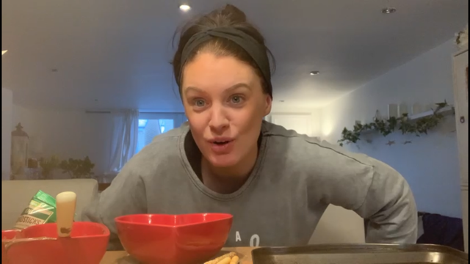**

**PICTURES OF ACTIVITIES THE YOUNG PEOPLE HAVE SENT IN**

***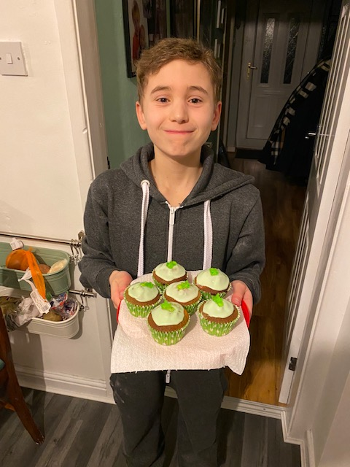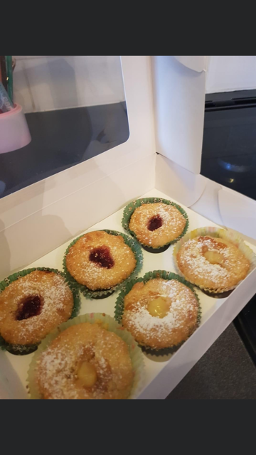***

***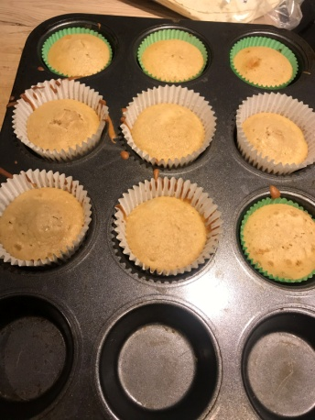 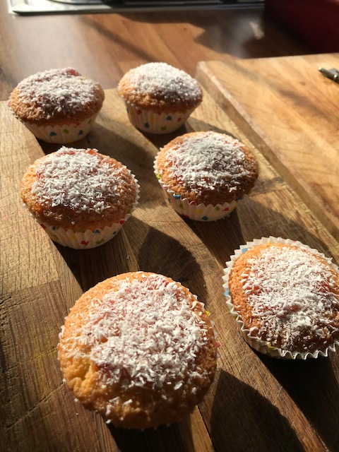***

***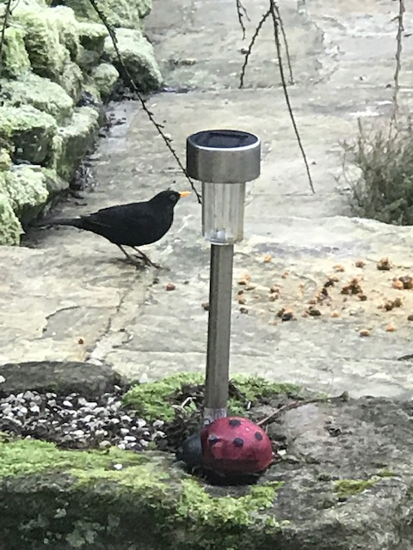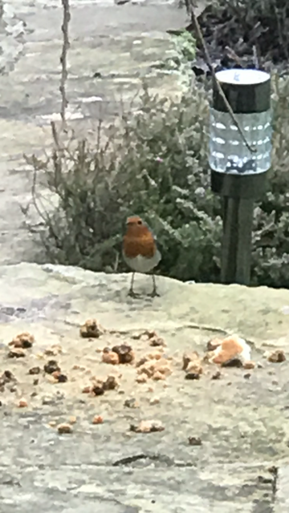  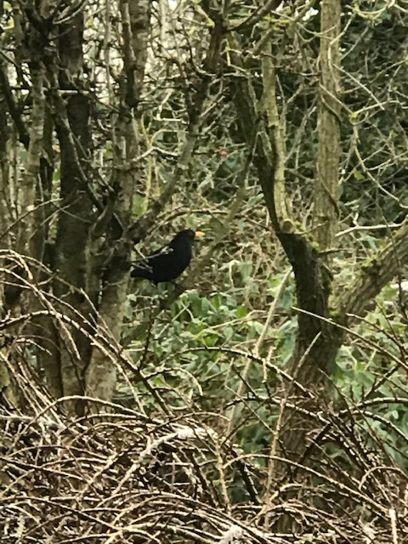***

***Number of beneficiaries***

*Throughout this quarter we have been engaging with 30 households plus several brought to our attention that needed extra help or resources on a more ad hoc basis.*

*While restrictions continue we have had several emails about young people who will turn 10 this year and want to get their names on the list for when we re-open.*

*Here are some of the packs we have sent out to the young people this quarter.*

*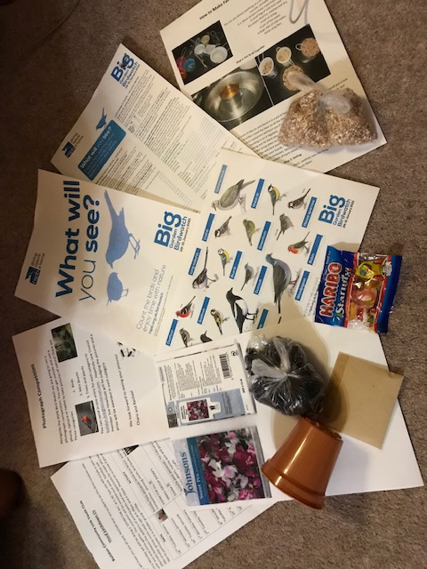*

*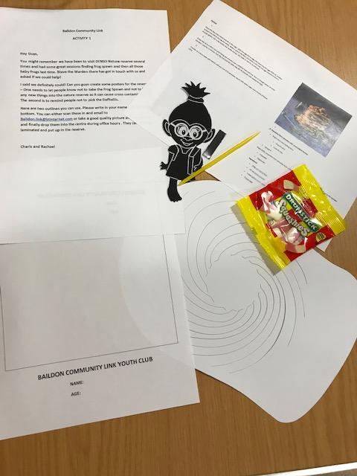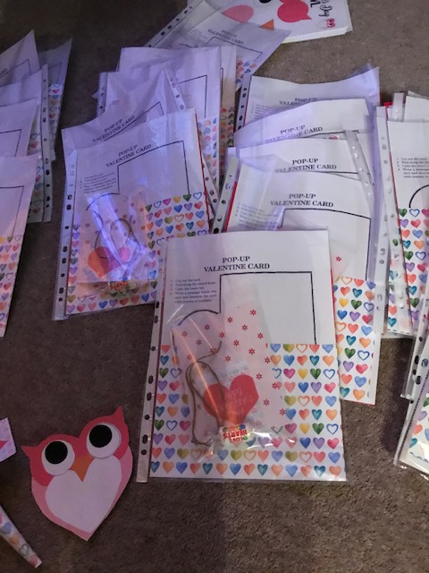*

***Partnership Work***

*During this time we have partnered with DENSO to get the young people to make posters to stop the removal of frogspawn and daffodils from the nature reserve. As well as making sure no one introduces anything new to the reserve too.*

*We have continued to receive and exchange pen pal letters from the young people for our over 55’s group; we look to further develop this in the next quarter.*

***Health and Wellbeing***

Following the positive feedback in the questionnaire we sent out, several young people would prefer smaller group ZOOM’s. So every other Tuesday we have smaller groups meet in Zoom. We have created these so they all have 1 or 2 friends in the group. These are opportunities to engage and support the young people more individually and play games that help them develop and have fun together.

This schedule also covered Internet Safety day –so we provided in a pack resources for the young people with scenarios and games to think about behaving safely online. This also included resources for parents on how to support young people whilst they are on screens so much in this pandemic. We have also set up lots of competitions to encourage the young people to get active and off screens. The first competition was a nature photography one and then a baking competition and a pancake competition for Shrove Tuesday. This was also supported with a family quiz to do at home to encourage positive relationships in the home setting.

Mental wellbeing was addressed in every session , providing a safe and open environment and opportunities for young people to share how they were and also how they had been during Lockdown to help them process past events.

For the safety of our volunteers we have asked them to continue shielding and not support in Youth Work at this time.

**Overall Summary**

We have continued to be creative and persistent in engaging with the young people and wider community, trying to meet immediate needs (food packages) and also support emotionally as well as fun and laughter in what may seem a tough time.

The response from the community and young people has been overwhelmingly positive from our questionnaire. We are reassured from their responses that we are meeting their needs and supporting them through this third Lockdown with new smaller groups and competitions.

**We look forward to returning to face to face sessions as soon as we are able to do so in line with Government Guidance!**