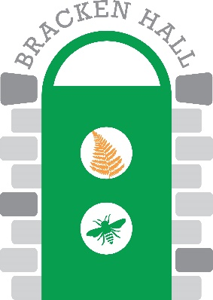

**Bracken Hall Countryside Centre: Manager’s Report, March 23rd 2021**

Richard White

**Attendance of public and evolution of opening at BHCC.** BHCC has continued to operate within the constraints of national/local COVID restrictions. This has included offering one family or a one-on-one pair the option to include entry to the Wildlife Garden as part of their outdoor exercise during the early part of the current lockdown, adapted recently to allow recreation and not just exercise. The Garden will remain the focus of our activities until at least mid-May, and entry will continue to be controlled at the gate, with track and trace in place, and COVID-secure provisions in place until legislation allows otherwise. Public attendance has remained strong with a peak number of 28 visitors during one 3.5 hour open session. Regarding the full opening of BHCC, we will adhere to the relevant guidance, for which we still need greater clarity (e.g. for hands-on displays, indoor activities, etc.). Two third-party groups have indicated that they will return to BHCC in some capacity in the near future.

**Volunteering situation.** The majority of BHCC’s regular volunteers have preferred to remain ‘on furlough’, as it were, with a core of 2 or 3 regularly contributing to open sessions. Two new volunteers have been recruited and have completed a Zoom-based induction session. A third new volunteer, a Syrian refugee that relocated to the area 5 years ago, has also submitted his application form, and sees BHCC as a place to allow him to improve his spoken English in an engaging environment. This will also provide an opportunity to prepare educational and activity cards/sheets that can be used by all. A number of volunteers have continued to work in the garden under conditions appropriate to address their COVID concerns on site.

**Tree works at BHCC.** Four small trees were coppiced and another was pollarded in March. The works were undertaken to a high standard by GP Gill. This has opened up specific areas to more sunlight, which will benefit the apiary and other trees. Further small works have been undertaken by staff/volunteers in accordance with the plan for the garden.

**Creation of BHCC Management Team.** As noted previously, extending the scope of input by volunteers has long been discussed for BHCC. Two open invitation Zoom meetings plus a number of other meetings were held, and have laid the foundations for what we hope will be a constructive and effective management team. The BHCC Management Team will report to the BTC Environment Committee, either through the Bracken Hall Manager, or, when appropriate, directly. The agreed structure for the Management Team is to have volunteers as Team Leaders for each of: Exhibition; Classroom; Outdoors; Support. Each team leader will coordinate a suite of activities and responsibilities, with the involvement of other volunteers, external parties, and BTC staff where appropriate. The Management Team will also include: Bracken Hall Manager; chair; BTC representative. To date, three of the team leader positions have been filled, and several more specific roles (e.g. scouting liaison, guided walks programme coordinator, etc.) have been filled.

**Funding application for building works update.** A decision on the large funding bid is due by late May.