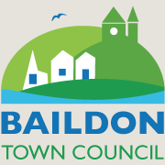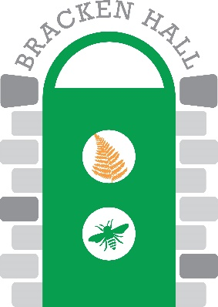

**Bracken Hall Countryside Centre: Manager’s Report, June 25th 2021**

Richard White

**Funding application for building works update.** The fabulous news is that the Countryside Centre has been awarded a grant of over £34000 from the Rural Development Programme for England (RDPE). This grant will support a project to improve the local facilities both on and off site. Primarily the grant will allow the construction of a new all-weather, multifunctional HUB. This will increase the flexibility, versatility and variety of activities that can be hosted on site and make the Centre an all-weather tourist attraction. The second aspect of the funding will improve BHCC’s connectivity to Saltaire and the Tramway and other access points to the area by improved signage for walkers, the erection of new information panels, and provide upgrades to the surfaces of a number of local footpaths/bridleways. Again, the BHCC Manager wishes to acknowledge the considerable efforts put into this project by Eddie and Ann Nash, two of the Friends of BHCC. The formal works programme is:

1. August/September: footpath/bridleway upgrades with signage/information panel erection
2. October-December: HUB construction work, redecoration of whole Centre.

Preliminary and preparatory work has already commenced by BHCC volunteers and BTC staff/councillors to ensure the site is ready for the main works. This will include the reworking of the Classroom’s storage, rationalization of equipment kept in the Classroom and in the Office/Store (which will become a designated store room due to the remodelling of the Classroom’s storage facilities), and remedial work will be undertaken in the Exhibition Room to remove obsolete and archaically located switches, the main ‘shop’ counter, etc., to provide a blank canvas going forwards once the redecoration has taken place. The preparatory phase of the works is being project managed by Councillor Alan Clubb and the BTC Clerk, and the main construction phases will be managed by the BTC Clerk and Eddie Nash. The role of BHCC Manager will be advisory throughout, allowing him to focus on ensuring that BHCC can offer as much public opening/events as possible throughout (see below).

**Attendance of public and evolution of opening at BHCC.** BHCC has continued to open its wildlife garden according to the COVID-19 precautions put in place by BTC/BHCC and any national/local restrictions in force. These pop-up openings are advertised as far in advance as the weather forecast permits, and have recently been restricted to weekend days, with daily visitor numbers ranging from 8 to 38. BHCC volunteer Paul King led three birding walks in May and June, attracting 10-22 participants. Other guided walks/outdoor activities are planned for the rest of the year. The Centre is also been used in a limited capacity by a number of third-parties including the Titus Salt School, Parkwood Primary and the Baildon Men’s Shed. BTC also has plans to host some meetings at BHCC. Going forwards, the whole site will be closed to the public from early October till mid-December. This has provided the opportunity for BHCC to go ‘on the road’ and take part in events at off-site locations.

**Volunteering situation.** Two new volunteers have been recruited and are already actively involved at BHCC. Several other volunteers have indicated that they are willing to return to ‘active duty’ once the national COVID restrictions have been lifted (provisionally 19th July).

**BHCC Management Team.** The Terms of Reference for the BHCC Management Team are presented as a separate document for approval by the BTC Environment Committee. The first few months of the Management Team has seen considerable input from the various team leaders, and from the volunteers involved in each team. This bodes well for the success of both the Management Team and for the Centre moving forwards.