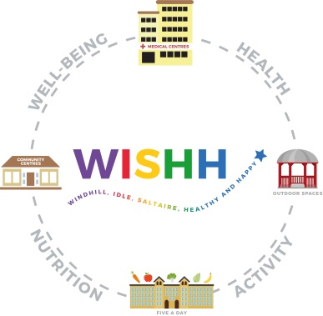

**WISHH Community Partnership (CP1)**

**CRITERIA AND NOTES FOR APPLICANTS**

1. Grants awarded will be to a maximum of £5,000.
2. Projects should benefit the WISHH Community Partnership area of Cottingley, Saltaire, Mid Baildon, Windhill and Idle
3. Priority will be given to new activities and ones which will become sustainable by encouraging volunteers and service users in their ongoing delivery
4. Initiatives which encourage healthy lifestyles and incorporate positive behaviours into a routine and in a group setting will be looked on favourably. As will those that promote self-help and personal responsibility?
5. Successful applicants must recognise and acknowledge the support of the partnership in publicity materials, where appropriate (for example on your website, in leaflets, programmes).
6. A copy of a group’s constitution and accounts should be provided, if the applicant is not constituted they must have agreement from a constituted body to administer the funding and vouch for the applicant group
7. If items are to be purchased two quotations should be provided [internet or catalogue OK]
8. A short report on the project and copies of receipts evidencing how all the money was spent should be submitted within six months of a grant being awarded.
9. If you are applying for activities for children or vulnerable adults you must include a copy of your organisation’s child/vulnerable adult safeguarding policy and enhanced DBS ID number(s) and expiry date(s) as evidence that checks have been completed.
10. Grants cannot be awarded for events/purchases that have already taken place, ie retrospective payments.
11. Please note that some of the data collected as part of this funding bid is shared with internal and external partners as well as the funded projects being publicised electronically, in funding reports, in the media and other methods of distributing the information.