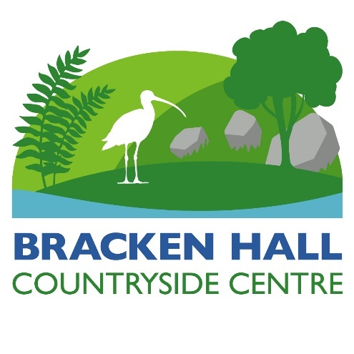 

**Bracken Hall Countryside Centre: Manager’s Report, February 14th 2022**

Richard White

**School group visits.** A number of school and college have already made enquiries about booking the Centre.

**Hire of BHCC.** Hire of BHCC is not restricted to school groups. BTC councillors and staff are encouraged to make use of the improved facility at BH and to advertise the Centre to prospective, appropriate groups.

**Volunteering situation.** We have lost a number of regular volunteers during the COVID hiatus. Volunteer numbers have always been marginal, so a recruitment campaign will form part of the reopening of the Centre. All BTC staff and councillors are requested to encourage possible volunteers to get involved with BHCC.

**Garden works at BHCC.** With the completion of major building works for HUB, volunteers and staff now plan to complete any pruning, tidying and other works required in the grounds. Pruning needs to be completed by the end of February.

**Reworking of BHCC prior to reopening.** Much preparatory work is required after the redecoration of other parts of BH. The office/store has been reassigned purely as a storeroom, allowing for a more ordered and functional storage space. This will take some devising and will require extra shelving and the creation of an effective inventory. At present, the Exhibition Room is full of material from other parts of the centre. This requires clearing ASAP to allow the re-erection of previous displays and then planning for future reworking and display updates can be undertaken.

**Continued success of BHCC Management Team.** The BHCC Management Team continues to prove an invaluable addition to the administration structure of BHCC. Management Team members continue to provide enthusiasm, much effort and energy, and great insight and innovation into how BHCC is run. In the absence of the BH Manager (unavailable due to isolating due to COVID), the Management Team held a successful and constructive meeting.

**Welcome of two BTC councillors to BHCC management structure.** Councillor Joe Ashton has temporarily joined the BH Management Team. Councillor Paul Sharkey has taken over the administrative responsibility for the HUB project. Both councillors are most welcome additions to the BH team. Former councillor, Alan Clubb, has agreed to become an informal external advisor for the whole BH project, a role he formerly held as a councillor. Again, his involvement is very welcome.

**HUB building works update.** Construction has taken considerably longer than was scheduled. Major delays have been due to building supplies and special orders (e.g. for the safety handrail/barrier). All major works are now complete. Outstanding tasks to be completed include the aforementioned handrail, update to the fire and intruder alarms, and new flooring in the Classroom.

**COVID update.** We had no COVID outbreaks or incidents during the period when BH was open. As such, the interventions put in place to protect volunteers, staff and visitors proved successful. The BH Manager is currently evaluating whether we should retain some of key interventions (e.g. paper hand towels, controlled access to site, hand sanitiser, etc.).

**Planned reopening day.** 2nd April, but if further delays are encountered, certainly by Easter weekend. BHCC will have a stall at the Heritage Day sundowner event at Roberts Park. Baildon Men’s Shed will take part.