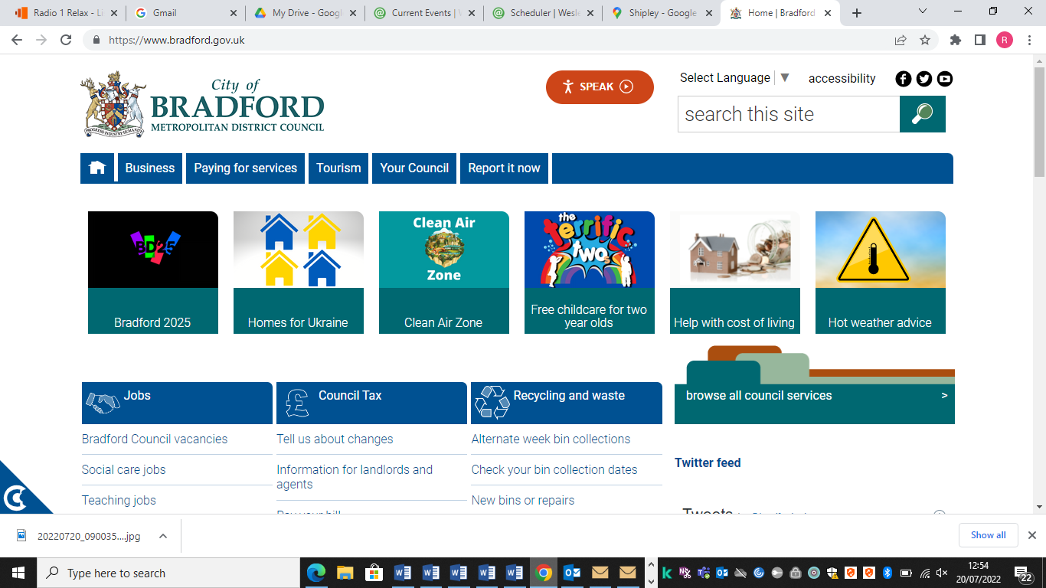****

**Bradford Youth Service. Shipley Locality**

**Shipley and Baildon Ward: Summer Youth Programme 2023**

**For Young people aged 11 years and over**

**ALL ACTIVITIES WILL BE FREE UNLESS STATED**

**For further information call 01274 437146 or email** [**carole.bywater@bradford.gov.uk**](mailto:carole.bywater@bradford.gov.uk)

|  |  |  |  |  |
| --- | --- | --- | --- | --- |
|  |  |  |  |  |
| **Monday 24th July**  Creative Arts Sessions  Design & create a tote bag, Music and Snacks  5.30pm to 7.30pm  Shipley Youth Project  2A Windsor Road Shipley BD18 3EQ | **Tuesday 25th July** | **Wednesday 26th July**  Invite Only Go Bowling Shipley 6.00pm for Shipley and Baildon young people  Baildon: Arts, Games Consoles, Snacks and Music 6.30pm to 8.30pm Baildon Methodist Church | **Thursday 27th July**  Information and Advice Session:16 to 25years.  3.30pm to 5.30pm  Shipley Youth Project 2A Windsor Road Shipley BD18 3EQ  Build A Bike: 4.30 to 6.00pm Shipley Hub Unit 5 Windsor Court BD18 3EU  Drop in Session: Music, and Food 5.00pm to 7.00pm  Shipley Youth Project 2A Windsor Road Shipley BD18 3EQ | **Friday 28th July** |
| **Monday 31st July**  Creative Arts Sessions  Design and create a t shirt, Music and Snacks  5.30pm to 7.30pm  Shipley Youth Project  2A Windsor Road Shipley BD18 3EQ | **Tuesday 1st August**  Sport Session Baildon 3.00pm to 4.30pm  Fisical Sports  Unit 19, Tong Park Industrial Estate Shipley BD17 7QD | **Wednesday 2nd August**  Invite Only Go Bowling and Games Room Shipley 6.00pm to 8.00pm    Baildon: Arts, Games Console, Snacks and Music 6.30pm to 8.30pm Baildon Methodist Church | **Thursday 3rd August**  Information and Advice Session: 16 to 25years: 3.30pm to 5.30pm  Shipley Youth Project 2A Windsor Road Shipley BD18 3EQ  Build A Bike Shipley Hub 4.00pm to 6.00pm Unit 5 Windsor Court BD18 3EU  Drop in Session: Music, and Food 5.00pm to 7.00pm  Shipley Youth Project |  |
| **Monday 7th August**  Creative Arts Sessions  Re design your clothes. Make a note book  5.30pm to 7.30pm  Shipley Youth Project  2A Windsor Road Shipley BD18 3EQ | **Tuesday 8th August**  Summer Family Fun Day open to all young people and families  Roberts Park 11.30pm to 15.00pm  Sport Session Baildon 3.00pm to 4.30pm  Fisical Sports  Unit 19, Tong Park Industrial Estate Shipley BD17 7QD | **Wednesday 9th August**  Invite Only Cinema Bradford Times and Film to be agreed  Baildon: Arts, Games Console, Food and Music 6.30pm to 8.30pm Baildon Methodist Church | **Thursday 10th August**  Information and Advice Session: 16 to 25years: 3.30pm to 5.30pm  Shipley Youth Project 2A Windsor Road Shipley BD18 3EQ  Build A Bike 4.00pm to 6.00pm  Shipley Hub Unit 5 Windsor Court BD18 3EU  Drop in Session: Music, and Food 5.00pm to 7.00pm  Shipley Youth Project 2A Windsor Road Shipley BD18 3EQ | **Friday 11th August**  **Cost £10.00**  Flamingo Land  Times and Pick up to be agreed |
| **Monday 14th August**  Creative Arts Sessions  Re design your clothes, make a book  5.30pm to 7.30pm  Shipley Youth Project 2A Windsor Road Shipley BD18 3EQ | **Tuesday 15th August**  Sport Session Baildon  3.00pm to 4.30pm  Fisical Sports  Unit 19, Tong Park Industrial Estate Shipley BD17 7QD | **Wednesday 16th August**  Invite Only  Bake off 5.00-7.00pm Shipley Youth Project  Sports and Large Games Competition Roberts Park. 6.30pm to 8.00pm | **Thursday 17th August**  Information and Advice 16 to 25years:  3.30pm to 5.30pm  Shipley Youth Project 2A Windsor Road Shipley BD18 3EQ  Build A Bike:  4.00pm to 6.00pm  Shipley Hub Unit 5 Windsor Court BD18 3EU  Drop in Session: Music, and Food 5.00pm to 7.00pm  Shipley Youth Project 2A Windsor Road Shipley BD18 3EQ |  |
| **Monday 21st August**  Creative Arts Sessions  Wall Mural  5.30pm to 7.30pm  Shipley Youth Project 2A Windsor Road Shipley BD18 3EQ  , | **Tuesday 22nd August**  Sport Session Baildon  3.00pm to 4.30pm  Fisical Sports  Unit 19, Tong Park Industrial Estate Shipley BD17 7QD | **Wednesday 23rd August**  Invite Only:  Games Night, Snacks and Music 5.00pm to 7.00pm  Shipley Youth Project  Baildon young people. Cinema Bradford 6.00pm to 9.00pm Film and Meeting points to be agreed | **Thursday 24th August**  Information and Advice 16 to 25years:  3.30pm to 5.30pm Shipley Youth Project. 2A Windsor Road Shipley BD18  Build A Bike: 4.00pm to 6.00pm Shipley Hub Unit 5 Windsor Court BD18 3EU  Drop in Session: Music, and Food 5.00pm to 7.00pm  Shipley Youth Project 2A Windsor Road Shipley BD18 3EQ |  |
| **Monday 28th August**  **BANK HOLIDAY No session today** | **Tuesday 29th August**  Free Sport Session Baildon 3.00pm to 5.00pm  Fisical Sports  Unit 19, Tong Park Industrial Estate Shipley BD17 7QD | **Wednesday 30th August**  Arts, Food and Music 6.30pm to 8.30pm  Baildon Methodist Church | **Thursday 31st August**  **Cost £3.00**  Yorkshire Wildlife Park Times and pick up point to be agreed  Build A Bike: 4.00pm to 6.00pm Shipley Hub Unit 5 Windsor Court BD18 3EU |  |
| **Please note plans can change at short notice.** | **For further information, call 01274 437146 or**  **Email:** [**carole.bywater@bradford.gov.uk**](mailto:carole.bywater@bradford.gov.uk) |  |  |  |