**Report of Cllr Foster on Road closure equipment for community events in Baildon.**

**13th May 2024**

**Events**

Baildon is host to many community events every year. Several of these require some roads to be closed, to enable the events to be held in an organised and safe manner.

Some of annual events that require road closures include;

* Harley Davidson ride-out on August bank holiday Sunday
* Baildon carnival children’s parade on the 2nd Saturday in July
* Baildon at Christmas/Christmas lights switch, various dates in December
* The Remembrance Day parade held on the Sunday nearest to the 11th November
* Community garden events, held at various times throughout the year.

The road closures are sometimes wholly organised and managed by BTC, some are organised by the individual groups themselves, and some managed jointly.

When BTC is not directly involved in the planning process we still attend planning meetings and make some financial contributions, along with organising volunteer road closure stewards.

When BTC applies to BMDC for the road closure orders, provides equipment and organises stewards we are reliant on others outside of Baildon to provide much of the road management equipment. However, BTC does not have their own road closure equipment. In the past we have been reliant on the generosity of Harden children’s gala committee and Ilkley Carnival association to loan us their road closure equipment.

We are fortunate that, due to the work of the Baildon carnival association, mutually beneficial partnerships have been formed with the Harden Gala committee and Ilkley Carnival associations. Baildon Carnival association are able to borrow their road closure equipment in return for our road closure stewards attendance at their parades. On the back of this agreement BTC has also been offered the loan of their road closure equipment for community events.

The support of Harden and Ilkley is very much appreciated, however this arrangement requires a significant amount of organising the collection and return of the equipment. And, invariably there are additional problems associated with transporting the equipment.

In addition, neither have all the equipment we specifically need. BTC office staff have on occasions, pulled out all the stops to print road closure sign at the eleventh hour. These are temporary signs as they are not durable.

BTC needs to work towards self-sufficiency, as soon as possible. Not only to alleviate transportation issues but to provide the correct signage for our specific road closures.

**Signage**

To cover all eventualities the following signage and equipment is required – see below.

These images and prices are from the cheapest supplier. The total cost based on these items is Total = £2002.28 inclusive of VAT.

Prices exclude VAT at 20%



[**XY8030 x 5 - Diversion Ahead - 600x450mm - 2mm Rigid Plastic With Metal Stanchion Frame**](https://www.safetysigns4less.co.uk/Traffic-and-Parking-Signs/Stanchion-Signs/Diversion-Ahead-Sign-with-Stanchion-Frame)

Description: Stanchion Sign with Frame and 6 Clips

Dimensions: 600 x 450mm

Material: 2mm Rigid Plastic

**£29.46**

**£147.30**



[**XY8035 x 15 - Road Closed - 600x450mm - 2mm Rigid Plastic With Metal Stanchion Frame**](https://www.safetysigns4less.co.uk/Traffic-and-Parking-Signs/Stanchion-Signs/Road-Closed-Sign-with-Stanchion-Frame)

Description: Stanchion Sign with Frame and 6 Clips

Dimensions: 600 x 450mm

Material: 2mm Rigid Plastic

**£29.46**

**£441.90**



[**7A033BR-R2 x 7 - Road Ahead Closed**](https://www.safetysigns4less.co.uk/Traffic-and-Parking-Signs/Temporary-Works-and-Traffic-Signs/Road-Ahead-Closed)

Size: 600 x 450 mm

Material: 2mm Rigid Plastic

**£24.27**

**£169.89**



[**XY7952 x 20 - Unfilled Sandbags Frame - Fixings - Single**](https://www.safetysigns4less.co.uk/Traffic-and-Parking-Signs/Stanchion-Signs/Single-Sided-Stanchion-Frame)

Description: Unfilled Sandbags

**£1.05**

**£21.00**



[**XY8067 x 7 - Clips For Metal Stanchion Frame (Pack of 6) - fixings**](https://www.safetysigns4less.co.uk/Traffic-and-Parking-Signs/Stanchion-Signs/Single-Sided-Stanchion-Frame)

Description: Pack of 6 Clips

**£2.42**

**£16.94**



[**XY7950 x 7 - Single Sided Metal Stanchion Frame - 600x900mm - fixings**](https://www.safetysigns4less.co.uk/Traffic-and-Parking-Signs/Stanchion-Signs/Single-Sided-Stanchion-Frame)

Description: Single Sided Stanchion Frame

**£19.01**

**£133.07**



[**XY0022 x 35 - Traffic Cone - 750mm**](https://www.safetysigns4less.co.uk/Safety-Essentials/Facility-Security-Products/Labels-Hazard-Marking/Traffic-Cones)

Description: Traffic Cone

Dimensions: 750mm

**£16.30**

**£570.50**



[**XY8031 x 3 - Diversion Arrow Left - 600x450mm - 2mm Rigid Plastic With Metal Stanchion Frame**](https://www.safetysigns4less.co.uk/Traffic-and-Parking-Signs/Stanchion-Signs/Diversion-Left-Sign-with-Stanchion-Frame)

Description: Stanchion Sign with Frame and 6 Clips

Dimensions: 600 x 450mm

Material: 2mm Rigid Plastic

**£30.44**

**£91.32**



[**7A027BR-R2 x 3 - Diversion Arrow Right**](https://www.safetysigns4less.co.uk/Traffic-and-Parking-Signs/Temporary-Works-and-Traffic-Signs/Diversion-Arrow-Right)

Size: 600 x 450 mm

Material: 2mm Rigid Plastic

**£25.55**

**£76.65**

**Subtotal**

**£1668.57**

Plus 20% VAT £333.71

Total = £2002.28

**Maps**

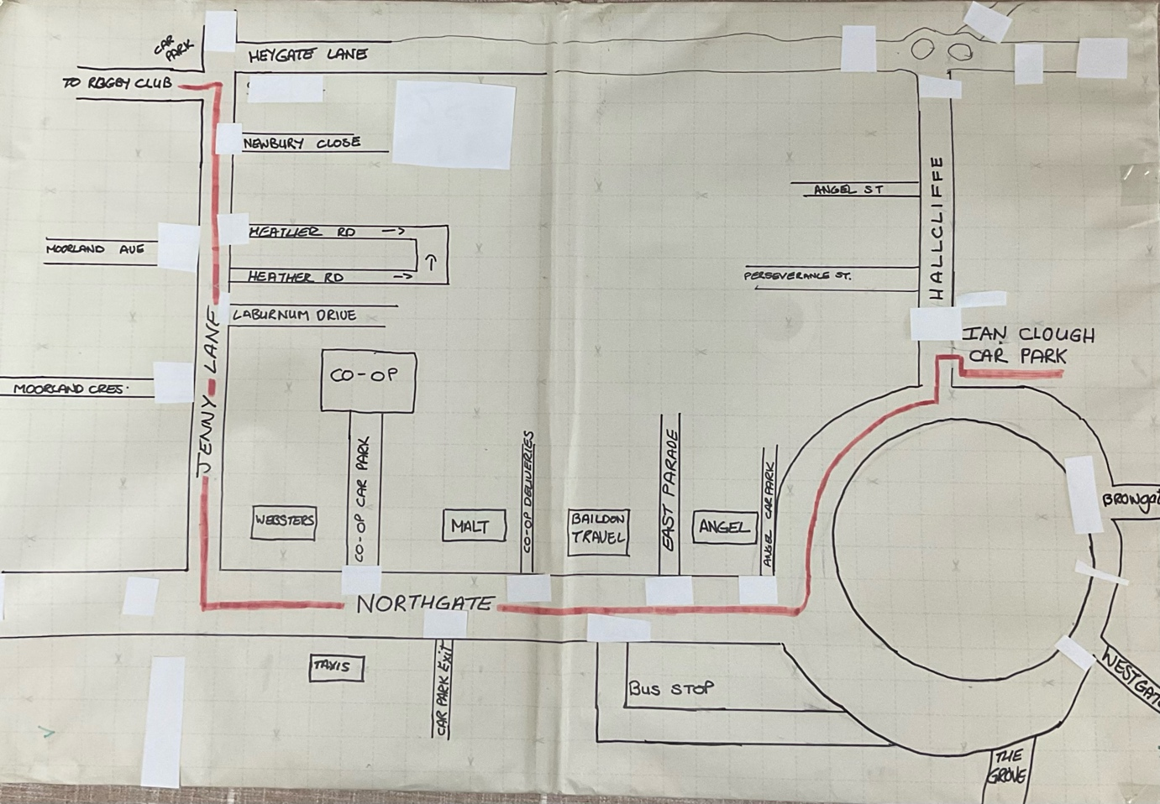The following maps show road closure for Baildon Carnival and Baildon at Christmas and diversions required. Map of carnival parade route shown in red.

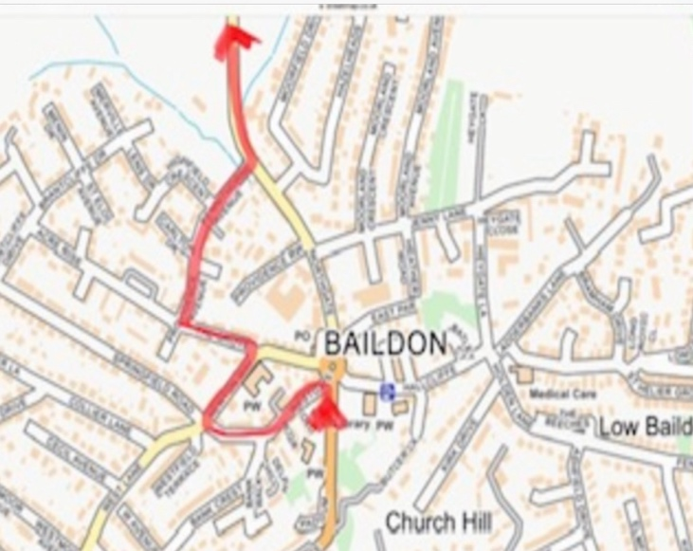Map of diversion for Carnival parade.

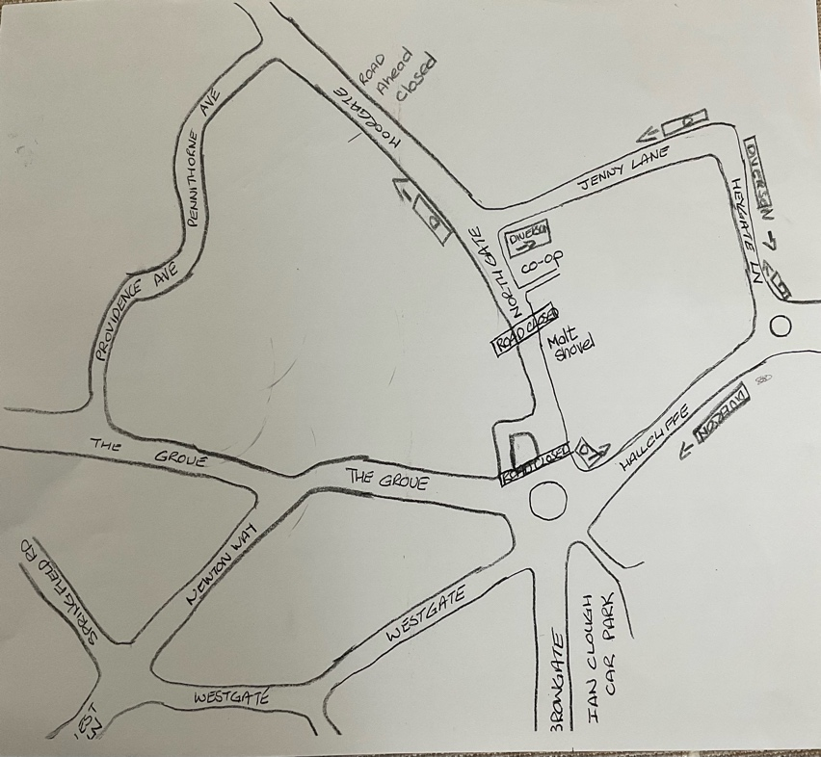Map of road closure and diversion for Baildon lights switch on.

**Funding**

Baildon Carnival association has been building a stock of road closure equipment over recent years. They have over 30 Hi Viz jackets, 10 walkie talkies, 5 hi tech body cams and a small amount of road signs. They have, with the financial support of BTC, trained 6 of their members to Lantra road management standards. Three are serving BTC members; Cllrs Ann Foster, Kate Griffn and Joe Ashton.

Baildon Carnival association has resolved to continue with purchasing equipment and has earmarked £500.00 this year for road closure equipment. Baildon Carnival have their own storage container supplied for free from Pickergills. BTC also has storage for free from Pickersgills.

By joint funding, we could purchase all the equipment we required and each could store their equipment separately. We would then be in a position to share the equipment to facilitate all Baildon’s road closure community events. Equipment would be easier to collect and there would be little organisation involved.

**City of Culture 2025 and Yorkshire Day**

At the moment we do not have any community activities planned that would necessitate a road closure specifically for City of Culture. However, we should remain mindful that there is a strong likelihood that there will be during 2025. Yorkshire day have suggested a road closure.

**Resolution**

Resolve to spend up to £1500.00 from General Reserves (by creating an Earmarked Reserve in 2024/25) to purchase road closure equipment to ensure our Baildon road closure community events are organised and managed efficiently to facilitate the safety of all concerned. Resolve to delegate to the Clerk the spending of this reserve in consultation with the Chair of Community Committee.