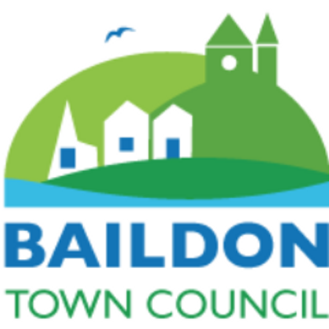 | BAILDON COMMUNITY HUBS  ACTIVITY REPORTS  (6-monthly)
Name of Hub:  Baildon Community Link | Date of report:  7th February 2024 to represent reporting due 31st March 2024 requested early by BTC

Plus: please send a current programme of activities at your premises or arranged by you in your neighbourhood.

1. | What evidence do you have that your activities are meeting the needs of the community?  (E.g. requests, surveys, attendance numbers, special factors, local knowledge and feedback) | We have a very busy timetable of activities (attached) which are all well used by local people. Our Centre is also a busy hub for private bookings including children’s parties at the weekend. We set up new activities in line with what local people want and in partnership, utilising information gathered by word of mouth, social media and survey feedback.
2. | What steps do you take to make sure that newcomers or vulnerable people are welcomed into your activities? | We have paid staff or volunteers dedicated to each activity group who keep an eye out for new people and ensure that they are welcomed and introduced to other people in the group. We will amend our activities to meet the needs of those with learning difficulties.
3. | Please give details of any new activities which have started in the current reporting period. | We have started a new dance class called Boogie with Tanya which is a very well subscribed wellbeing class, along with designing a new hygge programme and we have a new regular booking of a philosophy group. In addition we have designed and run some hot chocolate stops for young people – beginning with the Coach Road area which has resulted in our junior club being fully subscribed at the time of writing this report with 20 attendees and a waiting list and we have worked in partnership to design and run a slow cooker project consisting of three elements – 30 free slow cooker distributed to vulnerable families, 100 sets of 12 community recipe cards produced and 2 slow cooker course in response to local interest which start 20th February (1 daytime and 1 evening).
4. | Please give details of any activities which have ceased during the current reporting period, and explain why? | No activities have ceased this reporting period.
5. | What advice or signposting services are you offering? | We met with colleagues from the NHS Talking Therapies and have been proactively promoting free counselling services in the community and to individual residents we meet who we think will benefit from these services which are currently undersubscribed for those aged 65 plus (although anyone aged 16 and up can access up to 12 weeks’ worth of free counselling). In addition, we have signposted people to our advice service which we run in partnership with Windhill Community Centre/the CAB, to food bank provisions, to free social services assessments, to helping hands and to wider activities in the local area and just beyond with a wide array of leaflets and booklets available to local residents at the Centre. We registered for Place2Be’s Children’s mental health week and youth workers have encouraged young people to talk about how they’re feeling at sessions to staff or volunteers present. We have been actively supporting the recent new recruit to St James including providing IT support around how to manage social media pages, community development knowledge and expertise, guidance about setting up new groups, including survey consultations and local strengths around the St James area alongside a listening ear during some teething difficulties.
6. | How many volunteers (formal or informal) are currently involved in delivering your activities (approx). | We have 25 Volunteers who are trusted with a whole array of responsibilities across the Centre and without their input we could not continue to run many of our activities. We have brought three new volunteers in this reporting period and are bringing in another new volunteer soon who will support as an ad hoc volunteer across a number of activities.
7. | Details of any outreach work undertaken within the current reporting period. | Outreach wise we set up some new hot chocolate stops to benefit young people on Monday and Tuesday evenings which have been running successfully for 4 weeks at the point of writing this. We are moving from Coach Road to the Co-op next week. In addition, we have ensured that we have put out posters and flyers wide and far, added content to the T & A and kept our own Centre advertising boards and leaflet stands up to date, alongside weekly social media posts about various activities taking place at our Centre. We have also worked in partnership with several groups, attending the Baildon Liaison meeting and registering an interest in the new Youth Partnership meeting that will take place later this month, alongside meeting with colleagues from Trust therapies about potential partnership work in the future.
8. | Number of residents attending your activities in an average week. | 730
9. | Anything you have been especially pleased about recently. | Baildon Community Link has welcomed another three new volunteers to join our team during this reporting period. We are also just going through an application form for another volunteer who is interested in acting as a cover worker across a number of activities which we are pleased about. Our volunteers continue to make a real difference to the lives of local residents who benefit from our activities and services and we are pleased about the benefit to local residents that our Centre makes. This reporting period two elderly women who live alone and one without family both told me that they belonged here and that is something that I’m really pleased about because this counteracts the effects of loneliness which can lead to poor mental health.
10. | Any concerns or difficulties that you want the Town Council to be aware of. | Baildon Community Link is concerned that this year to end March 2024 we anticipate a deficit of £13,760 according to our budget. We were affected significantly when we lost the £10,000 community development work grant from Town Council funding last year with the redistribution of the grant funding to local churches. We do have healthy reserves which will cover this deficit for a period of time. However, we are eating into our reserves and moving forwards we will need to consider ways of reducing the deficit further.
11. | Any gaps or plans identified for the future? | We hope to do some partnership work with Trust Therapies helping local people to gain access to up to 12 weeks of free counselling for those aged 16 plus.

Signed: L Maddison

