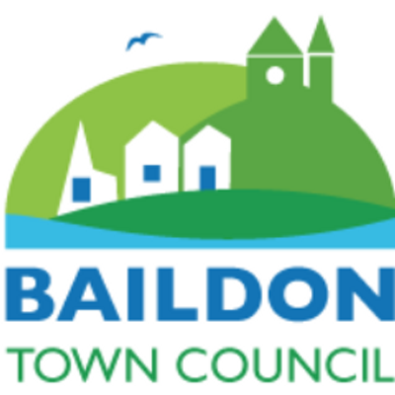 | BAILDON COMMUNITY HUBS  ACTIVITY REPORTS  (6-monthly)
Name of Hub: | Date of report:  20 May 2024

Plus: please send a current programme of activities at your premises or arranged by you in your neighbourhood.

1. | What evidence do you have that your activities are meeting the needs of the community?  (E.g. requests, surveys, attendance numbers, special factors, local knowledge and feedback) | I have carried out informal surveys and spoken to people attending activities at St James hub in order to get feedback on the activities they currently attend and to establish what other activities they would like to attend at our hub. I have also used our Facebook page to reach out to people to establish what kind of groups/activities people would like to see at the hub. I have looked at the activity timetables at the other hubs to identify any gaps.  Since the last reporting period the numbers attending all the groups has increased. The numbers at the weekly coffee morning have increased from 12 to between 28-30 per week. We have had new people attending who have then invited their friends along, I take this as an indication the need is there.  The Police Community support Officer, Warden and Neighbourhood housing officer regularly attend our Wednesday coffee morning, this provides a valuable service for our residents who attend. Individuals attending the coffee morning have said how useful they find it to be able to discuss any concerns they have with the relevant officer.  The Crafty knits group and the Art groups numbers have increased. These two groups are very popular, and the feedback is always very positive, again newcomers have been recommending the groups to their friends.
2. | What steps do you take to make sure that newcomers or vulnerable people are welcomed into your activities? | We acknowledge how important it is to ensure newcomers or vulnerable people are made to feel welcome. At our hub there are people at every group who lookout for newcomers and ensure they are found a seat and introduced to people. We know it’s a huge step for some people to walk into a room full of people when they haven’t been before and don’t know anyone. All group leaders go out of their way to make sure people are made to feel very welcome. At the art group and crafty knits there is no obligation for newcomers to take part until they feel happy doing so. Newcomers are free to observe and have a chat and a cup of tea until they feel comfortable about joining in. Individual members of the groups are always happy to share their skills and knowledge about their crafts.  Our Parish nurse attends the Wednesday coffee morning and offers a drop-in session for anyone who may wish to chat in private about any concerns they have.  Our Facebook posts always include the message ” Everyone is welcome”
3. | Please give details of any new activities which have started in the current reporting period. | During the last three months a Baby massage group has started, this has been very popular and due to high numbers of people wanting to attend we will be running two weekly groups from August.  From June we will be having a weekly mindfulness workshop, we ran a session during Mental Health awareness week and due to the excellent feedback and requests from individuals it was decided we would run weekly workshops.
4. | Please give details of any activities which have ceased during the current reporting period, and explain why? | No activities have ceased during this period
5. | What advice or signposting services are you offering? | We offer advice and signposting through our Parish Nursing service. Our Parish nurse (Carolyn Gomersal) offers a drop in service on Wednesday mornings between 10am-noon.  We use social media to signpost people to the Neighbourhood watch contact point at the library and the drop-in service for carers at Wesleys. We share what’s going on at other hubs on our Facebook page. Working with partner agencies we signpost people for Housing and Welfare benefit advice. We attend the Community hub meetings and the Baildon Liaison meeting. We display posters and leaflets offering help and advice these can be found on our display board and noticeboard. Copies of our newly updated “What’s on” guide can be found in the library and the GPs surgeries.
6. | How many volunteers (formal or informal) are currently involved in delivering your activities (approx). | We have approximately 15 volunteers. The volunteers we have are very dedicated and do a wonderful job.
7. | Details of any outreach work undertaken within the current reporting period. | The Parish nurse uses the local GP surgery and local community groups to promote the service.  We plan to work with partner agencies to offer support to lonely and isolated individuals in our community.
8. | Number of residents attending your activities in an average week. | The numbers attending our activities are increasing. In an average week we have approximately 280 residents attending our activities
9. | Anything you have been especially pleased about recently. | During Mental Health awareness week, we arranged several activities including Mindfulness and Candle making workshops. The whole week was a great success and we received excellent feedback from attendees. I worked alongside our Parish nurse to offer as much help and advice about how to look after our mental health. We distributed advice leaflets and signposted people to relevant agencies.  I arranged a litter pick during Baildon Spring clean week. Residents, an Incommunities housing officer, Council Warden and a Ward Councillor all helped on the day. Dave McDougal who coordinates litter free Baildon supplied bags and litter pickers. It was a great opportunity to go out into the local community to offer our support to local residents.
10. | Any concerns or difficulties that you want the Town Council to be aware of. | Our timetable is very busy with Hirers and Community groups. We plan to adjust the timetable slightly to create space for another group.
11. | Any gaps or plans identified for the future? | I have identified there is a need for a Toddler group and/ or an expectant parent and babies’ group. We plan to set up a group in the near future.

Signed: J Bower

